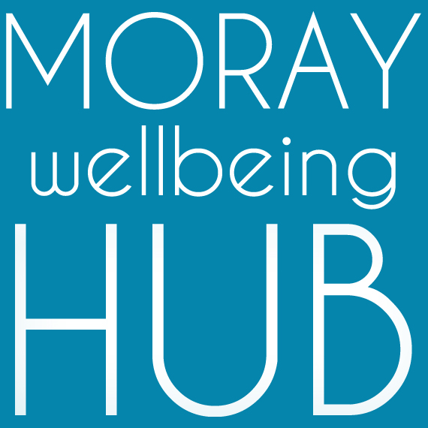
Role description: Admin Support, (self-employed/employed)

Accountable To: Co-ordination leads

Role Overview
With excellent communication skills and experience of a proactive approach to administration, this role supports our delivery team to deliver the objectives of projects and support our social movement and enterprise; increasing our network, connecting partners and supporting community members to navigate our projects and achieve their wellness goals.

Responsibilities and Duties
This project administrative role supports communications, record keeping and maintaining resources to deliver project objectives.

- take a values-led peer approach to all elements of the project role including as a proactive team member
- perform administration tasks such as answering phone calls, taking notes, scheduling meetings, emailing, social media updates, maintaining calendars, online booking management for courses, maintaining record keeping.
- offer signposting advice and information to via face-to-face in localities, telephone and email contact
- provide timesheets, quotes and work to agreed timescales
- maintain databases and undertake any other administrative duties linked to monitoring
- visible as a peer and Champion of Moray Wellbeing Hub, modeling recovery values
- have good awareness of the social movement and enterprise activity and current projects
- attend and complete appropriate training, supervision and mentoring
- support community events, promotional activity and creative delivery
- support delivery team members around admin and community development roles.

Qualifications & skills

Essential:
- proven organisational, administrative and IT experience and skills, and the ability to manage a variety of tasks
- good communication and interpersonal skills
- experience in working with community members of diverse experiences and challenges
- passion for peer-led social change and community empowerment
- the ability to deal with information in a confidential manner and respond with sensitivity
- a flexible and non-judgemental approach to people and work.
- peer qualifications and experience: e.g. Peer 2 Peer, WRAP or PDA in peer support. (either hold this prior to appointment or willing to work toward gaining Peer 2 Peer pass next time course is delivered)

Desirable:
- good knowledge of Moray wide services and supports for wellbeing
- experience of Ticket Tailor, Mailchimp, Trello and social media platforms
- qualifications in business administration and experience as a personal assistant
- creative and research experience and skills
- willing to travel and work unsocial hours

How we work: Moray Wellbeing Hub CIC is an ambitious and peer led social enterprise that believes passionately in supporting mental wellbeing in Moray. We are fast paced, entrepreneurial and self-directed in the way we work. We expect any volunteer, freelancer or employee to take ownership and autonomy in their role, showing a proactive approach to finding and sharing relevant information, whilst also working collectively. A core value of self-directed working is communication and feedback which we actively encourage you to take the lead with. We avoid complicated hierarchies or structures, aiming to equally empower everyone to make decisions and take accountability for their actions. Some of the work you will be expected to undertake is remote home working with other work being delivered in community spaces and venues across Moray. This is not a typical administration role where you will be working full hours behind a computer, this is a creative administration role where outreach and training will be built within the role, if you are not willing to travel or work in public settings this role is not for you.

Diversity and inclusion: In line with our aims of tackling stigma, empowering individuals and focusing on the strengths within us all, we celebrate diversity and inclusion at MWH. The strength of our business is built on wide-ranging personal experiences, and we pride ourselves on being an Equal Opportunities Employer.

Rate of pay & hours: £11.03 employed, flexible hours linked to various project requirements, working days and times will be discussed at interview (Our core hours are typically Monday – Friday, 09:30 – 15:00 however some work maybe required out with these days and time, notice will always be provided where possible).

