Early Interventions in Psychosis (EIP) Advisory Group

Terms of Reference

Page

- Role 2
- Remit 3
- Membership 3

- Member responsibilities 5

- Delegated authority 5

- Meeting arrangements 5

- Reporting and communication mechanisms 6

- Role
The Early Intervention in Psychosis Advisory Group has been set up as the successor of the Early Intervention in Psychosis Short Life Working Group which operated from November 2018 to March 2019.

This new group will report into the MHIP Advisory Group, and Healthcare Improvement Scotland’s (HIS) Performance and Clinical and Care Governance Committee. The advisory group will provide updates to and seek updates from relevant interdependent groups, see figure 1.

The Advisory Group will provide advice based on their knowledge and experience. This will extend to the following areas of work;

- Evidence synthesis of EIP in rural and semi-rural areas
- National assessment of current practice in relation to first episode psychosis
- National learning system
- Accelerator sites
- Ensuring that people with lived experience are central to this work including areas highlighted above.

Figure 1.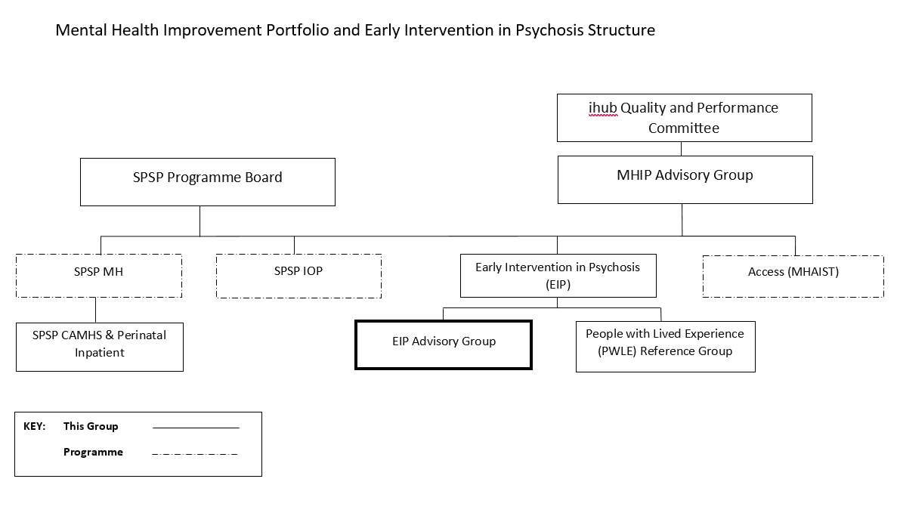

- Remit
The remit of the EIP Advisory Group is:
- To provide the relevant committee with strategic advice on the delivery of national programmes;
- To provide an advisory function to the relevant committee and input into key consultation exercises;
- To represent and communicate the views of key stakeholders and ensure these are considered throughout the delivery of the programme;
- To report on relevant performance information in relation to the delivery of the programme.

- Membership
The membership of the EIP Advisory Group will be flexible to accommodate new emerging issues and others may be co-opted onto the group for a particular purpose. Membership will always contain the following core members:

- Co-chairs (2) – an appropriately senior level individual from a Scottish NHS board and or health and social care partnership actively engaged with programme and a paid person with lived experience of psychosis.
- Clinical lead(s) – Providing subject matter expertise around specific programmes of work.
- Clinical representation – a member of the MDT providing subject matter experience
- MHIP Portfolio lead
- Programme Lead (HIS) – Improvement Advisor
- Project Support (HIS)
- People with lived experiences: service users and carers
- Third sector representation
- Other key stakeholders e.g. Public Health Scotland
- Observers

The membership list is as shown below. The secretariat will maintain a current membership list and will record attendance at meetings.

Name | Job title | Organisation
Jane Cheeseman and XXXX (co-chairs) | National Clinical Lead - SPSP  XXXX | Healthcare Improvement Scotland
Roberta James | SIGN Programme Lead | Healthcare Improvement Scotland
Jennifer Halliday | National Clinical Lead – Access | Healthcare Improvement Scotland
Suzy Clark | National Clinical Lead - EIP | Healthcare Improvement Scotland
Ally Winford | Head of Young People’s Mental Health  Directorate | Scottish Government
Frances Simpson | Chief Executive | Support in Mind Scotland
Scott Whinnery | Team Lead, ESTEEM | NHS Greater Glasgow and Clyde
Susie Brown | Lead Clinician, ESTEEM | NHS Greater Glasgow and Clyde
Rajeev Krishnadas | Consultant Psychiatrist, ESTEEM | NHS Greater Glasgow and Clyde
Fiona Mackenzie | Service Manager | Public Health Scotland
Andrew Gumley | Professor of Psychological Therapy | University of Glasgow
Helen Griffiths | Lecturer in Clinical Psychology | The University of Edinburgh
NHS Forth Valley Accelerator Site representative | Varies | NHS Forth Valley
Roch Cantwell | Consultant Perinatal Psychiatrist | NHS Greater Glasgow and Clyde
Anne Joice | Programme Director – Psychological Intervention Team | NHS Education for Scotland
NHS Highland Accelerator Site representative | Varies | NHS Highland
Michelle Miller | Portfolio Lead – MHIP | Healthcare Improvement Scotland
Rachel King | Strategic Planning Advisor | Healthcare Improvement Scotland
April Masson | Improvement Advisor | Healthcare Improvement Scotland
Kayleigh Watson | Senior Project Officer | Healthcare Improvement Scotland

- Member responsibilities
4.1 Responsibilities
It is assumed that each member will, as appropriate, reflect the views of their organisation or peer group and/or provide expert advice or opinion in their area of expertise. Some additional responsibilities expected of members include:
- Members should attend the majority of advisory group meetings (attendance by members will be monitored to ensure stakeholder representation is fair and maintained);
- Members will be responsible for ensuring timely communication between their organisation or peer group and the advisory group (where their function on the group is to represent the views or their organisation or peer group);
- Members will actively contribute to the work of the advisory group;
- Members will identify a nominated deputy to attend meetings which they are unable to attend, ensuring representation from their organisation or peer group.
- Programme leads will prepare a written highlight report on progress achieved between meetings
4.2 Ways of working
- The EIP Advisory Group will: Remain focussed on the effective delivery of the programmes
- Ensure that the work of the Advisory Group aligns with the efficiency and productivity agenda.
- Ensure that the work of the EIP Advisory Group is in line with relevant equality and diversity policy and legislation, applicable to all NHS boards and health and social care partnerships.

- Delegated authority
The EIP Advisory Group is intended to be a small effective operational advice-giving forum, based on the membership’s varied, multi-disciplinary experiences.

Members will be authorised to provide advice without recourse to consultation within their own organisations, and are requested to cascade information about the work of the MHIP more widely within their own organisations. Members will be held personally accountable for the delivery of tasks.

This group does not hold the authority to make any decisions on the delivery of the programme.

- Meeting arrangements
6.1 Co-chairs
The meeting will be co-chaired by 1) an appropriately senior individual who holds a current lead position within a Scottish NHS board or Health and Social Care Partnership which is actively involved in delivering programmes, and 2) a paid person with lived experience of psychosis.

6.2 Frequency of meetings
The EIP Advisory Group will have its first meeting in October 2020 and thereafter will meet quarterly on a rolling programme of scheduled dates.
6.3 Quorum
It is expected that each meeting will take place when there is at least 66 % of the membership in attendance. Members who cannot attend in person or via teleconference can nominate a deputy at attend.
Attendance at the meeting will either be face to face, or by video conference (MS Teams).
6.4 Administration
The co-chairs of the EIP Advisory Group will finalise the agenda for each Advisory Group meeting in collaboration with the MHIP Portfolio Lead or deputy with other members free to suggest additions before the circulation date.
The agenda, routine work stream reports and any other supporting papers will be sent out at least five working days in advance of the meeting.
An action note shall be produced. The record of the meeting will clearly and succinctly record, what action will be taken, by whom and by when and how this will be reported back to the EIP Advisory Group. The action note will be recorded by applying the principle of collective responsibility or by referencing the job title against the relevant staff member concerned (relates to officers of Healthcare Improvement Scotland) or otherwise as agreed by the EIP Advisory Group members.
The first draft of the action note will be electronically submitted to the co-chairs for initial review and approval within three working days of the meeting. The draft record of the meeting will be approved by the EIP Advisory Group at the next meeting.
- Reporting and communication mechanisms
The EIP Advisory Group will report into the MHIP Advisory Group. There will be quarterly summary submissions with one full submission accompanied for a presentation annually.
Additionally, the EIP Advisory Group will report into Healthcare Improvement Scotland’s ihub quality Committee.

