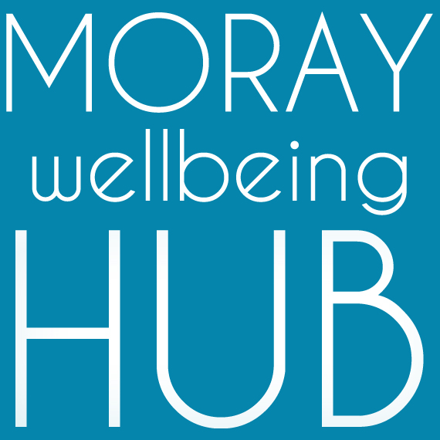
Moray Wellbeing Hub CIC
C19 Digital Access Fund: Expenses Form

- We are delighted to offer expenses toward digital connection to people in Moray to improve wellbeing during the COVID19 pandemic crisis.
- Due to social distancing rules people are relying on using online tools like Zoom, Google Classrooms, Skype, Slack, Facebook Messager, What’s App etc. This can mean an increase in costs for some people at a time when they may be facing extra financial challenges.
- We want anyone in Moray to be able to connect to our online events, Moray health and education services, their local community, friends and family to maintain wellbeing.

Key points
- Aim of support: To remove financial barriers to social connection online.
- Who can claim: Anyone in Moray who faces a financial barrier to connecting online.
- Maximum I can claim: Decisions are made based on assessing your need, but most costs are expected to be around £15 / under £50. You can claim more than once if there are funds available the next month. We can pay part of a cost if required.

Example expenses you can claim: Please contact us to discuss as we are open meeting your needs
- Small electrical equipment: e.g. Webcam to use with existing computer / holder for mobile phone
- Mobile data costs / contribution toward internet fees
- Larger items that we cannot cover we will look to support you to tap in to other local resources to solve your technology needs.

How to claim:
Part 1: BEFORE you purchase an item you want to claim

- Read this form carefully, complete section 1 and submit the form to us via email.
- We can complete this with you - contact Moray Wellbeing Hub via Hello@moraywellbeinghub.org.uk or by phone 01343 576219 (answerphone checked regularly).
- We aim to get back to you within 3 days, if you don’t hear from us please contact us and check we have your form.

Part 2: Purchases, bank transfers, evidence of purchase.

- If we agree to fund the item we will either purchase it directly for you to be delivered or arrange for a bank transfer.
- We will request evidence of purchase within 7 days via email – this needs to be a receipt or online invoice. We can help talk you through getting this if you are concerned.
- After 2 weeks we will contact you again to see if we can offer further support to ensure you are able to socially connect for wellbeing.

Many thanks to The Gordon & Ena Baxter Foundation and the
William Grant Foundation for funding support toward this access fund.

C19 Digital Access Fund Application Form
Name:  I’m 13 or under (delete if not applicable) | Today’s date
Email: | Phone numbers
What do you want to claim? (i.e. name of a piece of equipment)

What difference will this make for your wellbeing?

Are you claiming the full costs or are you looking for a contribution toward a full cost?

What existing technology are you using this with?
Laptop (operating system and model if known)
Phone (operating system and model if known)
Other (give details)
How many people in your household will benefit from this support?
(if you provide details on ages and challenges faced it will help us signpost you to further support)

OPTIONAL Question: Would you like any technical support to connect online? Any particular topics you are looking for support on?

OPTIONAL Question: Are you facing other financial or wellbeing issues you would like to let us know about? Again, this enables us to support linking you with other local resources.

Office section: To be completed by MWH team members.

Received by NAME and DATE: | Reply/contacted by phone NAME and DATE:
Details on signposting and topics of conversation explored. / Further action

Receipt information | Preferred payment details

To be signed by volunteer supervisor or line manager

Signed (name, designation & date) : ______________________________________________________

