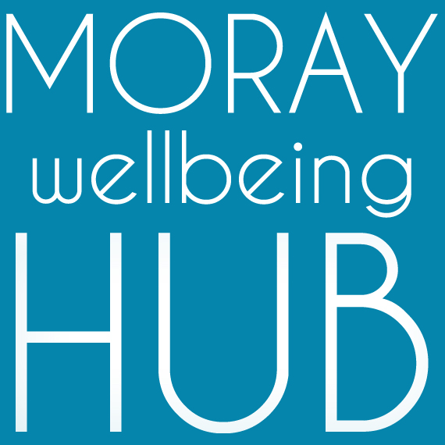
Job description: Website Developer, self-employed

Project: Wellbeing Connected Moray, March 2019 – February 2020

Reports To

Social Movement & Enterprise Lead / Moray Wellbeing Hub CIC Directors
Works closely with Volunteer Coordinator and Administration Support

Job Overview
With a passion for bending technology to meet our needs as well as a keen interest in our values and approach, this self-employed role supports our community development team to deliver the objectives of project Wellbeing Connected Moray and our social movement and enterprise. Connecting audiences of all ages and life experiences with solutions that simple, lasting and supportive.
Project information
Aiming to improve lives of those facing vulnerability and disadvantage in Moray by developing a new locality based holistic approach where the community helps itself. ‘Wellbeing Connected Moray’ will work across four localities (Cullen & Buckie, Elgin & Lossiemouth, Forres & Kinloss, Speyside) people will have better access to local wellbeing activity and services through the coordination of volunteers and organisations, and community activity such as outreach and creative events.

Responsibilities and Duties
The role is responsible for designing, coding, optimising and modifying websites, that are visually appealing and feature user-friendly design and clear navigation. Key tasks include the pathways signposting tool development and ensuring project communication systems work well.
- Working as a valued team member to achieve objectives and requirements of the job, using compassion, authenticity and mutuality.
- Working as part of a wider team that includes creatives such as a freelance graphic designer
- Maintaining and developing our of existing Wordpress sites
- Planning and prototyping new applications
- Proactive problem solving and SEO optimisation
- Testing, including sites and applications in different browsers and environments
- Compassionate and accessible IT Support and training
- Building and maintaining databases
- Estimating the time required to complete a job, providing quotes and working to budget
Qualifications & skills
Essential:
- Proven technical experience in JavaScript, JQuery, HTML, HTML5, CSS, CSS3, Web Programming Skills, E-Commerce, cross-browser compatibility, Web User Interface Design (UI), Security Principles, Object-Oriented Design, Web Services (REST/SOAP), Multimedia Content Development, API's
- Passion and enthusiasm for making accessible solutions for diverse groups
- A flexible approach when working in a team
- Excellent communication skills to interpret and negotiate briefs with clients
- Ability to work to short deadlines
- Being open to feedback and confidence to explain and sell ideas to colleagues
- Time management skills and the ability to cope with several projects at a time
Desirable:
- Experience in graphic design and use of Adobe Illustrator
- Hosting services
- Experience in working with community members of diverse experiences and challenges
- Passion for peer-led social change and community empowerment

