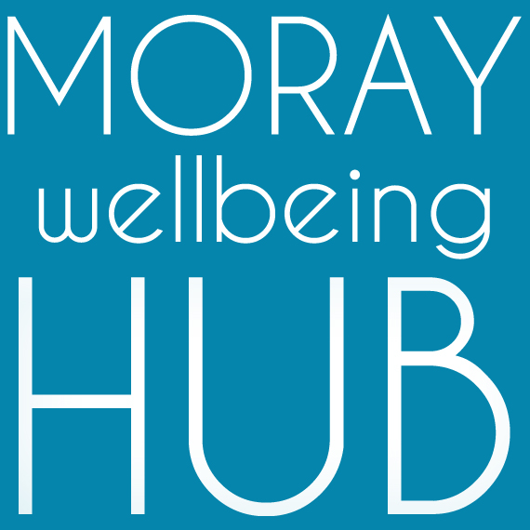
Job description: Graphic Designer, self-employed

Project: Wellbeing Connected Moray, March 2019 – February 2020

Reports To

Social Movement & Enterprise Lead / Moray Wellbeing Hub CIC Directors
Works closely with project Volunteer Coordinator and Administration Support

Project information
Aiming to improve lives of those facing vulnerability and disadvantage in Moray by developing a new locality based holistic approach where the community helps itself. ‘Wellbeing Connected Moray’ will work across four localities (Cullen & Buckie, Elgin & Lossiemouth, Forres & Kinloss, Speyside) people will have better access to local wellbeing activity and services through the coordination of volunteers and organisations, and community activity such as outreach and creative events.

Job Overview
With a passion for creativity and communication, as well as a keen interest in our values and approach, this project self-employed role supports our development team to deliver the objectives of project Wellbeing Connected Moray in Moray localities and promote our social movement and enterprise. Compassionately bringing elements of our unique approach to life for audiences of all ages and life experiences in a lively yet accessible style. Key taks will be working on signposting online tool ‘pathways’ and exploring how to bring to life creative ideas from people in localities.

Responsibilities and Duties
Prepares visual presentations by designing project art and copy layouts.
- Ensuring the project brand remains consistent in communications
- Working as a valued team member to achieve objectives and requirements of the project, using compassion, authenticity and mutuality.
- Working as part of a wider team that includes other creatives and our Website Developer
- Estimating the time required to complete a job, providing quotes for time and working to budget
- Developing design briefs that suit our needs
- Thinking creatively to produce new ideas and concepts and developing interactive design
- Using innovation to redefine a design brief within time and cost constraints
- Presenting finalised ideas and concepts
- Working with a range of media
- Proofreading to produce accurate and high-quality work
- Maintaining and providing appropriate technology including Adobe licensing

Qualifications & skills
Essential:
- To have own license for Adobe Creative Cloud or Adobe Creative Suite, with proven experience in using adobe Illustrator and InDesign
- Passion and enthusiasm for design, with a creative flair
- A flexible approach when working in a team
- Excellent communication skills to interpret and negotiate briefs with clients
- Ability to work to short deadlines
- Good presentation skills and the confidence to explain and sell ideas to colleagues
- Time management skills and the ability to cope with several projects at a time
- Accuracy and attention to detail when finalising designs
- Being open to feedback and willing to make changes to your designs
Desirable:
- Experience in working with community members of diverse experiences and challenges
- Passion for peer-led social change and community empowerment

