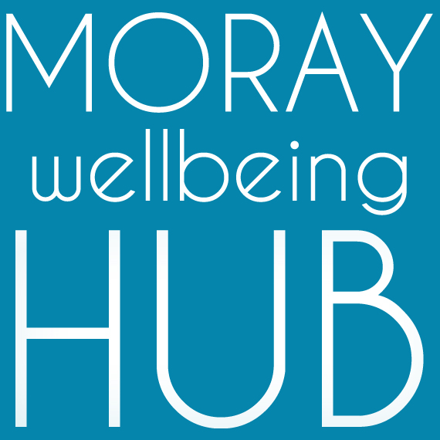
Job description: Volunteer Supervisor, self-employed or flexible contract

Project: Moray Peer Connectors Project, April 2019 – March 2020

Reports To

Project Coordinator / Social Movement & Enterprise Lead
Works closely with Administration Support

Project information:
In four locality areas (Forres area, Elgin & Lossiemouth, Speyside, Buckie & Cullen), the project aims to harness life experiences in self-management and recovery to better connect, inspire and support community members as part of an integrated partnership approach in Moray.

Job Overview
With a strong track record of compassionate and value-led supervision of volunteers, this community development role supports our diverse team to deliver the objectives of project ‘Moray Peer Connectors’ and our social movement and enterprise.

Responsibilities and Duties
The role is responsible for supervising and mentoring volunteers delivering one-to-one and group-based activity. Working closely with the Project Coordinator who has oversight of volunteering activity.
- work as a valued team member to achieve objectives and requirements of the job, model the values of our organisation in your actions as a peer - compassion, authenticity and mutuality.
- monitor, support, motivate and accredit volunteers and their work
- have good awareness of the social movement and enterprise activity and current projects
- attend and complete appropriate training in peer-approaches, including supervision and mentoring as part of personal development
- maintain databases and undertake any other administrative duties
- contribute to our ongoing Participatory Action Research approach by sharing regular reflections
- support the Project Coordinator in their role including to;
  - ensure there is appropriate support and training for volunteers,
  - research and write volunteer policies and procedures, including risk assessments
  - generate appropriate volunteering opportunities and role descriptions
  - promote volunteering (internally and externally) through recruitment and publicity
  - interview and recruit volunteers, ensure they are appropriately matched and trained
Qualifications & skills
Essential:
- strong interpersonal skills and experience in working with community members of diverse experiences and challenges
- proven experience of managing volunteers and a strength-based mentoring approach
- passion for peer-led social change and community empowerment
- excellent communication skills including around challenging topics
- the capacity to inspire and motivate others
- the ability to deal with information in a confidential manner and respond with sensitivity
- strong knowledge of your localities services and supports for wellbeing
- good organisational, administrative and IT skills and the ability to manage a variety of tasks maintain records and produce clear reports
- a flexible and non-judgemental approach to people and work.
Desirable:
- Qualifications in business and management studies, human resource management, social work, or youth and community work.
- Peer qualifications and experience: e.g. Peer 2 Peer, WRAP or PDA in peer support

