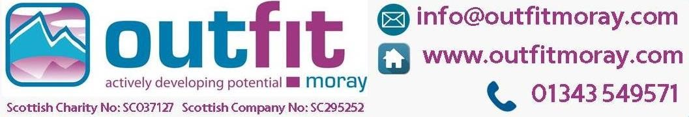

26th Jan: Bushcraft Burns.
Celebrate the Bard’s birthday in true Outfit Moray style, with a Burn’s Supper cooked over an open fire. Participants will be collecting firewood and learning how to build a fire and a shelter. If our team are overcome by the moment, they may even address the haggis! Cost: £15 per person Arrive: 9.45am, Depart: 10am, Return: 1pm

From 16th Jan: Bike Maintenance Classes
Covering everything from basic bike maintenance, to gears and brakes, our weekly bike maintenance classes are just £15 each and are held at our premises on Shore Street, 6.30pm – 8.30pm.

16th Feb: Cycle Training Assistant Course, 9am to 5pm. The Cycle Training Assistant (SQF level 5) is a free, one day course delivered by Outfit Moray that enables you plan and deliver cycle training sessions using Bikeability Scotland 1 & 2 resources

2nd-3rd Mar: Outdoor First Aid Course, 9am to 5pm, Duffus Village Hall. Outdoor first aid knowledge is important for people leading groups of people in remote areas, or participating in any outdoor activities. Cost: £130pp. We have other Outdoor First Aid courses planned throughout the year, as well as Emergency First Aid at work on 16th May and Paediatric First Aid (tbc)

Spring Holidays: 1st - 12th April. Weekday outdoor adventure activities. See our calendar for full details. Meet at Outfit Moray 9.30am, return 4pm. £30 per child, no limit on number of spaces booked. We also have activities planned for all the Moray ASG occasional days and in-service days at £30 per child, which we hope will help ease child-care concerns for working parents. The ASG events will meet in the respective schools, to make everything a bit more straight-forward.

From 24th April: Weekly Adult Biking Group on roads and pathways with coffee and cake stops as a must and E-bikes are welcome. Free, but bring money for cakes and coffee. Leave Outfit Moray at 10am and return at 12.30pm

From 19th May: Family bike rides from Cooper Park in Elgin. Fortnightly, meeting at Elgin Library at 10am, returning 12.30pm. Free, but bring money for an ice-cream

We also have a series of Bike Skillz courses planned, the dates are being announced shortly.

Details of all the events can be found on our events calendar and if anyone has any questions, please get in touch.

Karen Cox
Fundraiser (Community and Corporate)
Outfit Moray, Shore Street, Lossiemouth, Moray, IV31 6PB
| T: 01343 549 571|Mob: 07775 737647|W: www.outfitmoray.com
Be a winner with an Outfit Moray Lucky Number!
