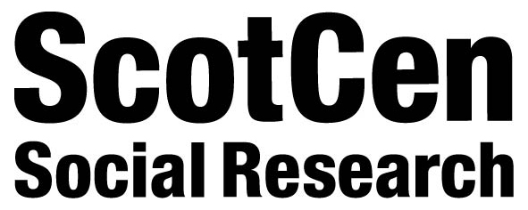
The Effect of Gambling Marketing and Advertising
Focus Group Privacy Notice
To better understand the effect of gambling marketing and advertising on children, young people and vulnerable people, Gamble Aware has funded a research project led by the University of Stirling. As part of this project, ScotCen Social Research is conducting focus groups. The focus group will gather information about awareness, knowledge and experiences of gambling and how it is advertised and marketed.
This privacy notice explains how your personal data collected through the focus groups are used and handled.
For the purposes of the focus group research, ScotCen Social Research is the data controller. The legal basis for collecting this information is legitimate interest and consent.
This research study is the result of a successful grant application to GambleAware. We want to find out about the awareness, knowledge and experiences of gambling and how it is advertised and marketed to young people and vulnerable people in Scotland, England and Wales.
How we got your details
We are contacting you through an organisation you engage with.
What happens to the information you provide
The personal data you provide in participating in a focus group will be treated with care and with full respect for your privacy. The information you provide will be treated confidentially. The information is used for research purposes only and is dealt with in accordance with data protection legislation. We will not publish the research results in a form that can reveal your identity.
Your name and any personal details will be stored securely. ScotCen will not pass your personal details to anybody without your permission, and will delete them on completion of the study unless specifically agreed otherwise.
Only the project team will have access to your personal data, and your data will not be shared with any third parties.

How long your information is stored for
All focus group responses are stored securely and confidentially under the terms of data protection legislation. The focus group transcripts will be stored by ScotCen Social Research for 2 years. They will then be securely destroyed.
Your rights
Taking part in the focus group is voluntary. You are free to withdraw at any time without consequence, and you do not have to answer all the questions.
Data protection legislation gives rights to individuals in respect of the personal data that organisations hold about them. These include the right to:
- access a copy of the information an organisation holds about them;
- object to processing that is likely to cause or is causing damage or distress;
- prevent processing for direct marketing;
- object to decisions being taken by automated means;
- have inaccurate personal data rectified, blocked, erased or destroyed in certain circumstances; and
- claim compensation for damages caused by a breach of the legislation.
We guard your privacy
We will treat the information you give us in the strictest confidence under the Data Protection Act 2018. The results collected are used for research purposes only. No one looking at the findings will be able to identify you in any way. You will never receive any junk mail as a result of speaking to us. We never pass on your details to other organisations for commercial purposes.
How to contact us
To find out more about the focus groups, or project as a whole, please contact Hannah Biggs Hannah.biggs@scotcen.org.uk or Andy MacGregor Andy.macgregor@scotcen.org.uk.
Complaints
If you have questions or concerns about how your personal data is collected or used, or if you believe we have not complied with your data protection rights you can contact NatCen’s Data Protection Officer by email at dpo@natcen.ac.uk.
You also have the right to lodge a complaint with the Information Commissioner’s Office. If you are unhappy with the way your personal data is being processed, you can report it to the Information Commissioner’s Office (ICO) at https://ico.org.uk/ or by calling the ICO helpline on 0303 123 1113.

