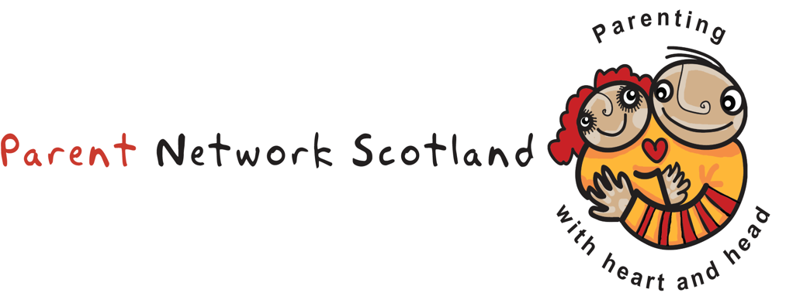
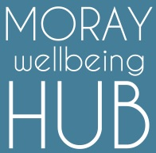
Parenting Matters 8-week Course

In partnership with,

Parenting Matters 8-week Course,
Thursdays for 8th February for 8-weeks.
Moray Resource Centre, Elgin.
FREE (Booking Required)

Would you like some timeout just for yourself?
Would you like to understand your
child/teenager better?

Are you interested in coming along to our FREE 8 week Parenting Matters Course, 2 hours/week, to find new ways of making family life work better? You can meet other parents and share experiences in a non-judgemental, relaxed environment. We are a friendly, informal organisation and all our groups are run by PARENTS for PARENTS.
Cuppa and biscuits provided

Parents Feedback from previous courses:
“I really enjoyed the group and I made new friends”
“I’m calmer recognizing my own needs and my child's”

Booking via: www.moraywellbeinghub.org.uk
Facebook (Moray Wellbeing Hub)
Or call Heidi on 07989331651
More course information at www.parentnetworkscotland.org.uk

