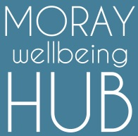
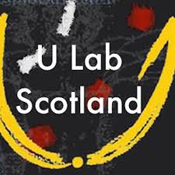
ULab Taster session
FREE
Dunbarney House Education Centre
Dr Gray’s Hospital
Elgin
11th September 2017, 6.30-8.30pm
(Refreshments provided)

“We can't solve problems by using the same kind of thinking we used when we created them”
Albert Einstein
We are at a precarious crossroads in the world, with many personal, social and global challenges arriving at a time when people have never been so isolated, nor communities so fragmented and disconnected.
How can we transform life for people in Moray?
How can we engage people in their wellbeing and health care?
U-Lab offers an effective participative model for profound personal and social change, the change coming from within the individual first through self-awareness, and then an awareness of the change needed to meet our emerging future.
Supported by the Scottish Government as a tool to explore radical change in Scotland, this online international course is FREE and participative.
The Moray Wellbeing Hub will be supporting a ULab group every Friday for this year’s course beginning 15th September – our intention will be around topics linked to mental health, health and social care transformation, population wellbeing and community empowerment.
There is no commitment to sign up for the full course, so if you are interested why not come along!

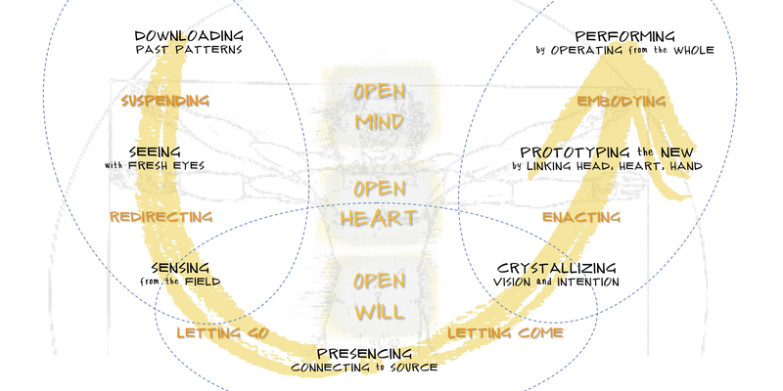
Find out more online:
Search: Eventbrite
Visit: moraywellbeinghub.org.uk
Visit: Facebook (moraywellbeinghub)

