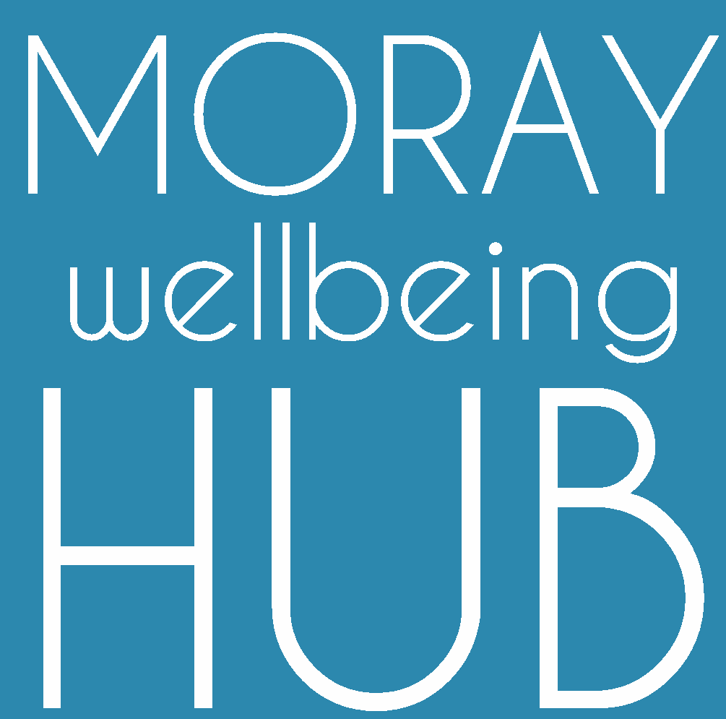

Organisation: Moray Wellbeing Hub CIC
Status: Non-Executive Directors (option to develop role as Executive Directors)
Closing date: 5/6/20, 12noon
Location: Moraywide
Website: www.moraywellbeinghub.org.uk

The Moray Wellbeing Hub CIC is looking to add to its board of directors as part of leading its innovative work. Our aim is to improve the wellbeing of people in Moray using activities that are founded on mutual peer support and an agreed set of values. We do this through delivering partnership activities such as training, awareness raising, supporting groups and individuals, as well as through setting up physical and virtual ‘safe’ spaces where people can share support and signposting.

We require a strong core of directors to develop our organisation, increase our financial stability, grow and develop our human resources, give strong leadership on our values, moving on to identifying new areas of development. This team aims to be greater than the sum of its parts, representing a diverse range of life experiences, interests and core skills. Recruitment will be from the existing Moray Wellbeing Hub Champions pool and advertised widely to encourage new Champions to join and consider the role.

Selection:
Applicants to the role of director will be decided by the existing three directors. We are looking to fill two positions in the team at this time, but may consider more if there are strong applications.

Skills required:
As we are looking for a team rather than a set of individuals, we will be looking for individuals that complement the existing directors’ skills to create a sustainable balance of practical and creative thinking, focusing on working well together as an authentic and supportive team. Of the two roles we seek to fill, one will specifically require skills and experience in business finance, the other may focus more on other interests and skills.

Peer2Peer:
You will be required to either already hold a pass in this course that enables use of peer-support values or be willing to undertake one within the first 6 months.

We aim to attract individuals with skills & experience such as:
(those in bold identified as areas of particular priority for this recruitment, but not essential)

- Finance, audit, accountancy and risk management
- Experience and understanding of the Third Sector, in particular health (wellbeing and issue based such as drugs and alcohol) and age specific (young people / older people)
- Community engagement
- Human resources and organisational development
- Social enterprise and/or community development
- Policy and local government
- Campaigning
- Evaluation and research
- Marketing
- Retail
- Business development
- Working knowledge of governance and how effective boards operate
- Managing change
- Creative approaches
- client/customer engagement
- Partnership working
- Strategic business planning

Core values & Directors Agreement :
Appointment will be based on completion of the application form, including a signed directors agreement, and suitable references (one from an existing MWH Champion). Key to selection will be ensuring that new directors embody the organisation values and support each other to do so.

Moray Wellbeing Hub core values & principles

Values ( HOW we work):
Authenticity | Open, honest and transparent communications.
Mutuality | Mutual respect and trust.
Community | A commitment to make best use of local resources & locality focus.
Empowerment | Proactive in addressing negative power dynamics on wellbeing
Coproduction | A willingness to work with and learn from others.
Strength based focus | A commitment to being positive and constructive.
Respecting rights | Promoting equality and awareness of rights.

Principles (WHAT we focus on):
Peer-support Recognising the value of intentional, mutual and authentic sharing of life experiences in inspiring recovery and wellbeing.

Anti-stigma Recognising and challenging all forms of stigma related to mental health including self-stigma.
Recovery Living a full and meaningful life, as defined by an individual
Inclusion All people are embraced irrespective of race, gender, disability, medical or other need.
Interdependency Increasing connection and community as core to wellbeing for all, moving beyond concepts independence from support of others as a desirable and achievable goal.

To apply, please send a completed application form to:

heidi@moraywellbeinghub.org.uk
Please title the email
‘MWH CIC Director Application Form’

The Deadline for applications is: Friday 6th June 2020 at 12 noon.
Application for Director: Moray Wellbeing Hub CIC – part 1
Name in full including any middle names:
(this is needed for Companies House registration)
I confirm that I know of no reason that I cannot undertake a director role (i.e. legal status)
Date of birth: | UK resident? Y / N (please delete)
Address (incl. postcode):
Directors statement:  I commit to the Directors agreement, core values and joining the Protecting Vulnerable Groups Scheme (PVG Scheme). I have also researched / have understanding of the legal aspects of the role. | Signed: …………  (if sent via personal email type your name here)  Date:……………

If you wish to discuss the Director role with an existing MWH Director please contact:
- Chris@moraywellbeinghub.org.uk
- Jean@moraywellbeinghub.org.uk
- Heidi@moraywellbeinghub.org.uk

Application for Director: Moray Wellbeing Hub CIC – part 2
Should applications be received that lack the core requirements or have insufficient information, the individual will receive strengths based support and feedback confidentially.
Intent: Why do you want to become appointed as a director for the Moray Wellbeing Hub CIC?

Strengths: What skills do you feel that you can bring to the board if you were appointed?

Insight: What challenges can you foresee in committing to this role? (For example, areas where you are aware of a lack of strength or external resources)

Resources: What have you in place to support your own wellbeing whilst carrying out your role?

Reference 1: Please provide a short statement of support from a fellow Champion that supports your application and shows your commitment to the values of the Moray Wellbeing Hub.

Referees Name (Champion):

Reference 2: Please provide a second referee who can support your application in terms of your valid skills for this role. Ensure that they are willing to be contacted regarding this application.
Name:
Contact details:
Relationship:

Moray Wellbeing Hub project: Directors agreement

Moray Wellbeing Hub Champions: Members of the social movement
Individuals who have signed up as MWH Champions and who take action to support MWH aims. This does not necessarily require a time commitment or skills base, just a willingness to be part of an active team of peers and use values based approaches.

Moray Wellbeing Hub CIC Directors: Legal role with responsibility for the social enterprise that resources and draws resource from the social movement
- Legal: Make a legal commitment to Companies House and have their details available in the public domain as part of this.
- Responsibility: Have decision making powers and financial responsibility within Moray Wellbeing Hub CIC.
- Visible peers: Are visible to others as a Champion, therefore the fact they have experienced crisis or challenge in their own wellbeing is also in the public domain (not all our champions choose to share their role).
- Committed: Make a commitment of time, no less than approximately 3 hours a week.
- Leadership: Lead by example under peer based values of the project.

Expectations: please tick all boxes and sign this document to show you have read all expectations, agree and understand this agreement

Champions:
- Have experienced crisis or challenge in their wellbeing
- Want to support the Moray Wellbeing Hub by taking action
- Agree to take action routed in our values and principles
- Endeavour to be aware of the key aims of MWH, the companies progress and activities, and know how to signpost to more information
- Agree to give feedback on their experiences of being involved in the project
- Agree to communicate with the project lead in advance
- if requiring additional resources for project work (expenses, transport, leaflets etc)
- if planning to represent the project at any meetings or events

Directors:
- Take a continuous personal development approach including obtaining a Peer2Peer pass
- Treat fellow directors and champions with unconditional high regard
- Are open about being a Champion
- Take legal responsibilities
- Commit to a minimum of 3 hours a week
- May be paid, if and when, funds are available in a relevant Executive Director role.

Signed………………………………………………..………………….. Date……………………………………..…..

