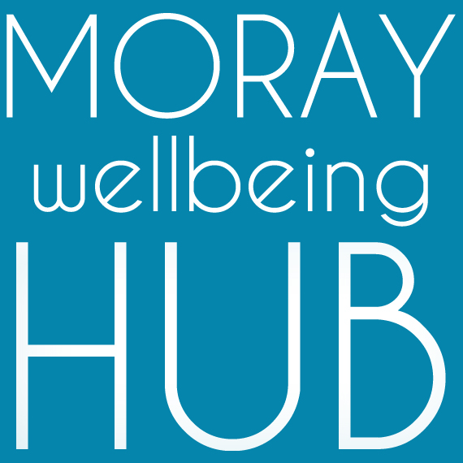
Job description: Peer-trainer / Peer-mentor, self-employed

Project: Wellbeing Connected Moray, March 2019 – February 2020

Reports To

Volunteer & Wellness College Coordinator / Social Movement & Enterprise Lead
Works within Peer Trainer Pool and alongside Volunteer Supervisors & Administration Support

Project information
Aiming to improve lives of those facing vulnerability and disadvantage in Moray by developing a new locality based holistic approach where the community helps itself. ‘Wellbeing Connected Moray’ will work across four localities (Cullen & Buckie, Elgin & Lossiemouth, Forres & Kinloss, Speyside) people will have better access to local wellbeing activity and services through the coordination of volunteers and organisations, and community activity such as outreach and creative events.

Job Overview
Holding a recent MWH QA pass this self-employed role harnesses skills in peer-led training and mentoring to deliver and support the objectives of Wellbeing Connected Moray and our social movement and enterprise; empowering, educating and connecting community members in localities to achieve their wellness goals whilst increasing our network and connecting partners – authentic, intentional and mutual.

Responsibilities and Duties
- visible leadership as a peer & Champion of Moray Wellbeing Hub, modeling recovery values
- work coproductively as a part of a Peer Trainer Pool to design and deliver high quality training in line with national and local recovery developments for this project
- regularly attend Peer Trainer Pool network meetings and take a mutual role, supporting any being supported by those with differing knowledge and experience
- take a Participatory Action Research approach, using reflective practice as part of ongoing personal development and maintaining a MWH QA pass.
- attend and complete appropriate training, including supervision and mentoring
- have good awareness of the social movement and enterprise activity and current projects
- undertake administrative duties linked to monitoring and evaluation
- work alongside project Volunteer Supervisors and Administration Support
- keep up to date with national developments in recovery and any specialist subjects you deliver in, incorporate knowledge within practice and share learning with Peer Trainer Pool
- provide quotes and work to agreed timescales
- support the Volunteer & Wellness College Coordinator in their delivery role including to;
  - coordinate MWH key deliverables for this project, including: Wellness College, Peer Trainer Pool, Peer Connectors, and our social movement for change (Champions)
  - monitor, support, motivate, supervise and accredit team members and their work
  - design, review and update courses and resources
  - engage in partnership approaches with a range of stakeholders
  - support community events, promotional activity and creative delivery

Qualifications & skills
Essential:
- MWH QA pass achieved within last 12 months
- peer and/or training qualifications and experience relevant to courses you wish to deliver: e.g. Peer 2 Peer, WRAP, LLTTF, SMHFA, SIPP etc
- strong interpersonal skills and experience in working with community members of diverse experiences and challenges
- strong knowledge of Moray wide services and supports for wellbeing
- passion for peer-led social change and community empowerment
- excellent communication skills including around challenging topics
- the capacity to inspire and motivate others
- the ability to deal with information in a confidential manner and respond with sensitivity
- organisational, administrative and IT skills
- a flexible and non-judgemental approach to people and work.
- willingness to travel and work unsocial hours
- proactive approach to working as part of a team of diverse experience and skills
Desirable:
- Qualifications in business and management studies, human resource management, social work, or youth and community work.
- Creative and technology experience and skills
- Research experience and skills

