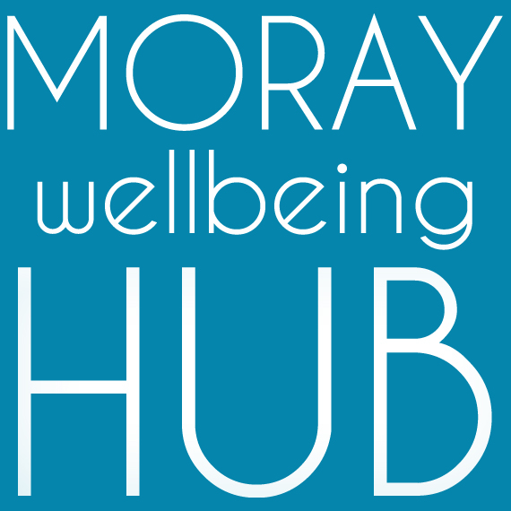
Job description: Administration Support, employed role

Project: Wellbeing Connected Moray, March 2019 – February 2020

Reports To

Volunteer & Wellness College Coordinator / Social Movement & Enterprise Lead
Works closely with Volunteer Supervisors & Peer Trainer Pool

Salary / rate of pay : £10.50 per hour, part-time hours

Job Overview
With excellent communication skills and experience of a proactive approach to administration, this role supports our community development and leadership team to deliver the objectives of project Wellbeing Connected Moray and our social movement and enterprise; increasing our network, connecting partners and supporting community members to navigate our projects and achieve their wellness goals.
Project information:
Aiming to improve lives of those facing vulnerability and disadvantage in Moray by developing a new locality based holistic approach where the community helps itself. ‘Wellbeing Connected Moray’ will work across four localities (Cullen & Buckie, Elgin & Lossiemouth, Forres & Kinloss, Speyside) people will have better access to local wellbeing activity and services through the coordination of volunteers and organisations, and community activity such as outreach and creative events.

Responsibilities and Duties
This project administrative role supports communications, record keeping and maintaining resources to deliver project objectives.

- take a values-led peer approach to all elements of the project role including as a proactive team member
- perform administration tasks such as answering phone calls, taking notes, scheduling meetings, emailing, social media updates, maintaining calendars, writing web copy.
- offer advice and information to via face-to-face in localities, telephone and email contact
- provide timesheets, quotes and work to agreed timescales
- support the Social Movement & Enterprise Lead in a personal assistant capacity
- maintain databases and undertake any other administrative duties linked to monitoring
- visible as a peer and Champion of Moray Wellbeing Hub, modeling recovery values
- have good awareness of the social movement and enterprise activity and current projects
- attend and complete appropriate training, supervision and mentoring
- support community events, promotional activity and creative delivery
- support Volunteer Supervisors and Peer Trainer Pool members around admin processes
- support the Volunteer & Wellness College Coordinator as part of their community development role.

Qualifications & skills
Essential:
- proven organisational, administrative and IT experience and skills, and the ability to manage a variety of tasks
- good communication and interpersonal skills
- experience in working with community members of diverse experiences and challenges
- passion for peer-led social change and community empowerment
- the ability to deal with information in a confidential manner and respond with sensitivity
- a flexible and non-judgemental approach to people and work.
Desirable:
- peer qualifications and experience: e.g. Peer 2 Peer, WRAP or PDA in peer support
- good knowledge of Moray wide services and supports for wellbeing
- experience of Survey Monkey, Mailchimp, Wordpress, and social media platforms
- qualifications in business administration and experience as a personal assistant
- creative and research experience and skills
- willing to travel and work unsocial hours.

