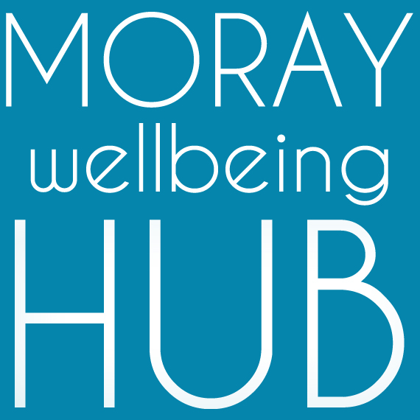
Job description: Volunteer Supervisor, self-employed

Project: Wellbeing Connected Moray, March 2019 – February 2020

Reports To

Volunteer & Wellness College Coordinator / Social Movement & Enterprise Lead
Works closely with Administration Support

Project information
Aiming to improve lives of those facing vulnerability and disadvantage in Moray by developing a new locality based holistic approach where the community helps itself. ‘Wellbeing Connected Moray’ will work across four localities (Cullen & Buckie, Elgin & Lossiemouth, Forres & Kinloss, Speyside) people will have better access to local wellbeing activity and services through the coordination of volunteers and organisations, and community activity such as outreach and creative events.

Job Overview
With a strong track record of compassionate and value-led supervision of volunteers, this self-employed community development role supports our diverse team to deliver the objectives of project ‘Wellbeing Connected Moray’ and our social movement and enterprise.

Responsibilities and Duties
The role is responsible for supervising and mentoring volunteers delivering one-to-one and group based activity. Working closely with the project Volunteer & Wellness College Coordinator who has oversight of volunteering activity.
- work as a valued team member to achieve objectives and requirements of the job, model the values of our organisation in your actions as a peer - compassion, authenticity and mutuality.
- monitor, support, motivate and accredit volunteers and their work
- have good awareness of the social movement and enterprise activity and current projects
- attend and complete appropriate training in peer-approaches, including supervision and mentoring as part of personal development
- maintain databases and undertake any other administrative duties
- support the Volunteer & Wellness College Coordinator in their role including to;
  - ensure there is appropriate support and training for volunteers,
  - research and write volunteer policies and procedures, including risk assessments
  - generate appropriate volunteering opportunities and role descriptions
  - promote volunteering (internally and externally) through recruitment and publicity
  - interview and recruit volunteers, ensure they are appropriately matched and trained
Qualifications & skills
Essential:
- strong interpersonal skills and experience in working with community members of diverse experiences and challenges
- proven experience of managing volunteers and a strength-based mentoring approach
- passion for peer-led social change and community empowerment
- excellent communication skills including around challenging topics
- the capacity to inspire and motivate others
- the ability to deal with information in a confidential manner and respond with sensitivity
- strong knowledge of your localities services and supports for wellbeing
- good organisational, administrative and IT skills and the ability to manage a variety of tasks maintain records and produce clear reports
- a flexible and non-judgemental approach to people and work.
Desirable:
- Qualifications in business and management studies, human resource management, social work, or youth and community work.
- Peer qualifications and experience: e.g. Peer 2 Peer, WRAP or PDA in peer support

