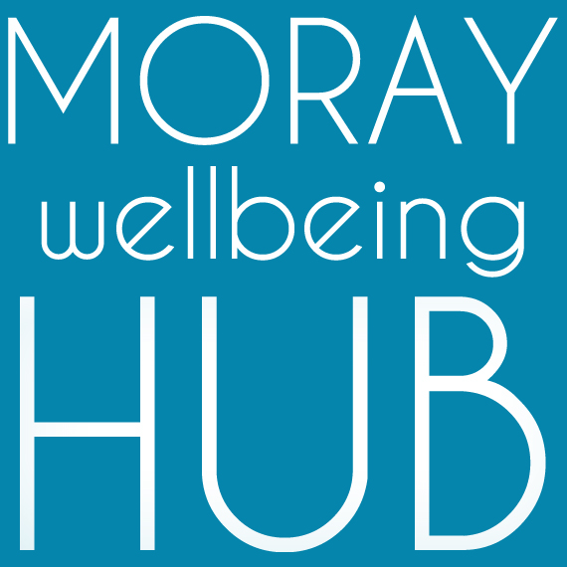
Job description: Volunteer & Wellness College Coordinator, employed

Project: Wellbeing Connected Moray, March 2019 – February 2020

Reports To

Social Movement & Enterprise Lead / Director team
Works closely with project Volunteer Supervisors & Administration Support

Salary / rate of pay & hours: £14.50 per hour for 164h per month

Project information
Aiming to improve lives of those facing vulnerability and disadvantage in Moray by developing a new locality based holistic approach where the community helps itself. ‘Wellbeing Connected Moray’ will work across four localities (Cullen & Buckie, Elgin & Lossiemouth, Forres & Kinloss, Speyside) people will have better access to local wellbeing activity and services through the coordination of volunteers and organisations, and community activity such as outreach and creative events.

Job Overview
With a strong track record of coordinating projects and diverse teams of volunteers and freelance specialists, this community development role supports our leadership team to deliver the objectives of project Wellbeing Connected Moray and our social movement and enterprise; increasing our network, connecting partners and supporting community members to navigate activities and achieve their wellness goals.

Responsibilities and Duties
This operational role is responsible for coordinating our resources to deliver project objectives.
- work as proactive team member including with specialists in graphic design and web development
- visible leadership as a peer and Champion of Moray Wellbeing Hub, modeling recovery values
- coordinate MWH key project activities, including: Wellness College, Peer Trainer Pool, Peer Connectors, and our social movement for change (Champions)
- have excellent awareness of the social movement and enterprise activity and current projects
- attend and complete appropriate training in peer-approaches, including supervision and mentoring
- design and maintain databases and undertake any other administrative duties linked to monitoring
- attend partnership meetings and networks, and work coproductively with multiple agencies
- offer advice and information to via face-to-face, telephone and email contact
- host community events, promotional activity and support creative delivery
- coordinate and support Volunteer Supervisors and Administration Support
- interview and recruit volunteers, ensure they are appropriately matched and trained
- support the Social Movement & Enterprise Lead in their strategic and management role including to;
  - manage budgets and resources, including the reimbursement of expenses
  - research and write policies and procedures, keep up to date with legislation
  - supervise and mentor team members
  - ensure there is appropriate support, opportunities and training for team members
Qualifications & skills
Essential:
- peer qualifications and experience: e.g. Peer 2 Peer, WRAP or PDA in peer support
- strong interpersonal skills and experience in working with community members of diverse experiences and challenges
- strong knowledge of Moray wide services and supports for wellbeing
- proven experience of managing volunteers and a strength-based mentoring approach
- passion for peer-led social change and community empowerment
- excellent communication skills including around challenging topics
- the capacity to inspire and motivate others
- the ability to deal with information in a confidential manner and respond with sensitivity
- good organisational, administrative and IT skills and the ability to manage a variety of tasks
- a flexible and non-judgemental approach to people and work.
Desirable:
- Qualifications in business and management studies, human resource management, social work, or youth and community work.
- Creative and technology experience and skills
- Research experience and skills
- Willing to travel (including national and international travel) and regularly work unsocial hours.

