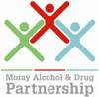
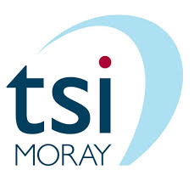
CONNECT MORE
Celebrating and promoting partnership working and connecting people up.
25 March 2019
Alexander Graham Bell Conference Centre, Moray College UHI

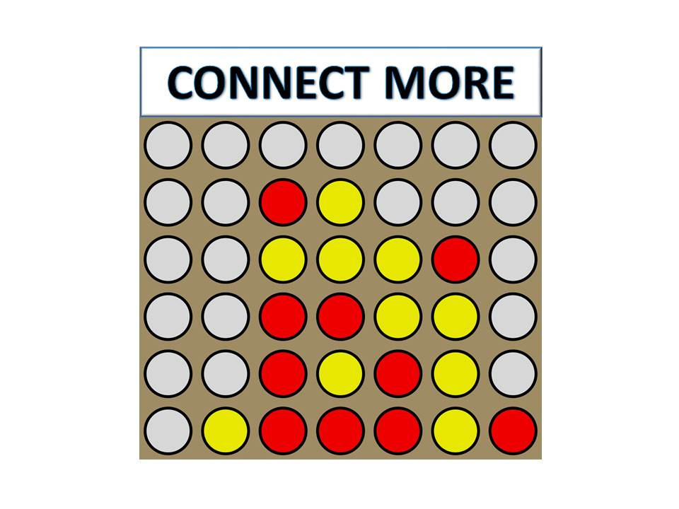

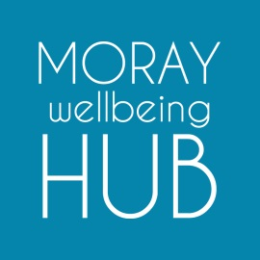
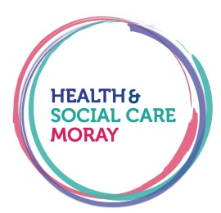
PARTNERSHIP EVENT
Connect More – Celebrating and promoting partnership working

09:30 Registration/Coffee

10:00 Welcome and Introduction
- Key Note Speakers

10:30 Bingo Activity - Elidh Brown, tsiMoray

11:00 Comfort Break/Coffee

11:15 Workshops
- SMART Recovery Group Arrows
- Harm Reduction & Young People CREW
- Locality Management Groups

12:15 Feedback

12:45 Lunch

13:30 Keynote Speaker, Heidi Tweedie – Moray Wellbeing Hub

13:50 Workshops
- Wellbeing Group Session – Arrows
- MEOC (Making every Opportunity Count) – Health Improvement Team
- Peer Workshop – Wellbeing Hub Champion

14:50 Evaluation

15:00 Coffee and Next Steps

Booking Form
Connect More
25 March 2019 – Alexander Graham Bell Conference Centre
Moray College UHI, Elgin
Name:

Organisation:

Address:

Town:

Postcode:

Is This Address
Private or Work?
Telephone:

Email:

Sign up to receive email communications about future events and news. | YES NO
Morning Workshop:  Please tick which workshop you would like to attend.  Limited spaces available. | SMART Recovery  Harm Reduction & Young People  Locality Management Groups
Afternoon Workshop:  Please tick which workshop you would like to attend.  Limited spaces available. | Wellbeing Group Session  MEOC (Making Every Opportunity Count)  Peer Workshop
Please return to:
Louise McKenzie, Moray Alcohol and Drug Partnership, 11 North Guildry Street, Elgin, IV30 1JR or, email to louise.mckenzie@moray.gov.uk by 15 March 2019

