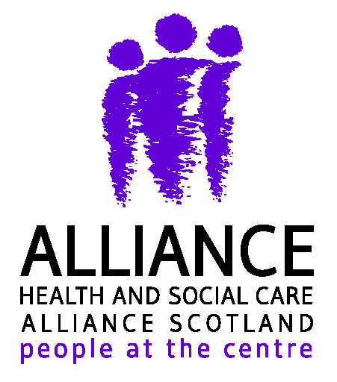

Self Management Reflective Practice Session
Elgin Academy School, Elgin
9.00am - 12.30pm
Wednesday 13th Feb OR Thursday 14th Feb

9.00 | Arrivals and networking
9.20 | Introduction and setting the scene
9.40 | What’s your best story?
10.00 | Real life examples – case studies
10.25 | Brainstorm
10.35 | Comfort Break
10.50 | Challenges and solutions
11.30 | Time for action
11.45 | Checking back in
12.00 | Feedback and evaluation
12.15 | Close

To book a place contact:
chloe.booth@nhs.net
01343 567119

Please leave your email address and date you can attend the course

