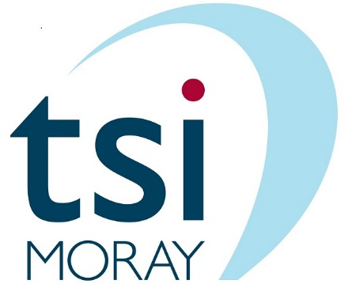

Frontline Forum: #You Choose 1/2/3
Programme
Friday 1st June 2018
12.30 to 2 pm (Doors open from 12 noon)
The Inkwell, Frances Place, Elgin

12.30pm | Welcome and Housekeeping  Elidh Brown, tsiMORAY and Louise McKenzie, MADP  NB Comfort Breaks  Please take comfort breaks and refreshments as you require.
12.35pm | Presentation by Sacro  How we/the people we work with benefit from building partnerships  Kathleen Donaldson, Service Team Leader, Sacro
12.50pm | Group Discussion  We might discuss: What difference do small grants make (when public sector budgets are stretched so tight)? What difference does working with partners make? How do community groups/volunteers add value? What do we achieve together that we could not do working alone? How does working with other groups/organisations better serve our community/the people we work with?
1.05pm  1.20pm | Presentation by Arrows  Bethannay McAllister, Support Worker – plans for the Arts Group  Davey Blackie, Support Worker – sharing perspectives from people taking part in stakeholder deliberation  Funding: #You Choose 3 and the Scotch Whisky Action Fund  Elidh Brown, tsiMORAY and Douglas Meikle, Scotch Whisky Association  Group Discussion  #You Choose 3 will focus on Working Together, as well as further developing Digital Participation  We might discuss: How can we promote our project idea online and in real life? How can we get more people involved to support us and the development of our project idea/community group/people we work with? How will we know we can trust the digital voting process?
1.35pm | Film – ‘Direct’  (This film may contain strong language and violence, and may not be suitable for young people under 15 or young people under 18)  Garry Collins, Out of the Darkness Theatre Company  Group Discussion  Does this film challenge assumptions or stigma? In what ways?  What was good about the film? What would make it even better?
1.55pm | Event Summary and Evaluation  A chance for each participant to share a word on today’s events
Accessibility | Please note the venue has access for people using wheelchairs.
Tailored towards adults | This event is tailored towards adults and may not be suitable for children. The film includes a young person as one of the key characters within the story, and therefor this event may be of interest to some young people. Please discuss with event organiser to check if this event is suitable for the young people you work with. Please check with/seek consent from parents or guardians where appropriate.
Please make us aware of participation challenges | If there any challenges or barriers to participants from your project attending this event please could you let me know, and specify if there is something we could do that would enable participation, either at this event, or in the future.
Filming and Photography | We may ask you to sign a consent form on arrival if we plan to film or take photos. Please let us know if you/a participant would prefer not to be photographed or included in filming.

