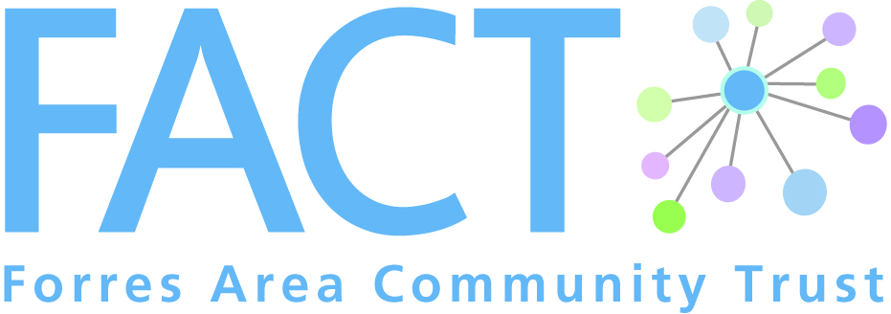
1 Leask Road, Forres, IV36 1SW

Phone: 01309 674388
Email: info@forresarea.org
Web: www.forresarea.org

Person Specification Cameron’s Champion

Essential | Advantageous
Personal Qualities  - Warm, friendly and encouraging  - Interested in supporting other people  - Reliable, honest and trustworthy  - Able to maintain confidentiality  - Empathetic and understanding  - Willingness to learn  - Conscientious and self -motivated  - Able to keep calm in stressful situations  - Flexible | - Clean driving licence and access to a car  - Good sense of humour
Knowledge/Understanding | - Understanding of the concept of befriending  - Knowledge and understanding of issues faced by older people  - Knowledge of available social and leisure activities in the area
Experience | - Previous volunteering experience
Skills
- Good communication/ interpersonal skills
- Good listening skills
- Ability to recognise and respect other people’s boundaries
- Ability to recognise and apply own limits and personal boundaries
- Ability to make use of support and supervision
- Commitment to ongoing development and training
- Commitment to provide feedback on the befriending relationship
- Commitment to work within organisational boundaries

Values
- Accepting the person for who they are – being non-judgemental
- Respecting others as being of equal worth
- Respecting other’s choices, lifestyles and rights
- Not imposing own values and beliefs
- Appreciating differences (e.g. race, culture, gender, etc)
- Able to view someone as a person, not a stereotype

