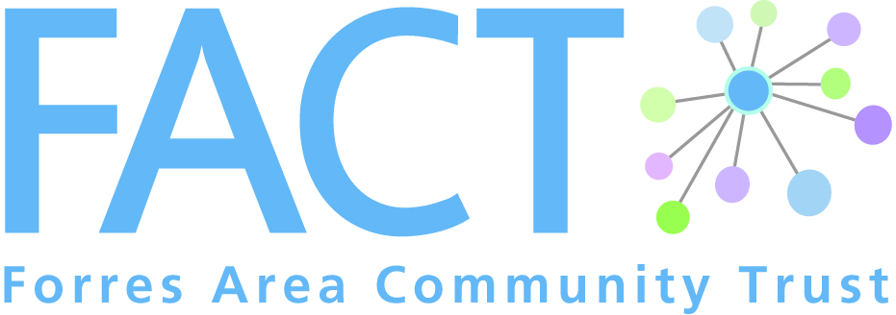
1 Leask Road, Forres, IV36 1SW

Phone: 01309 674388
Email: info@forresarea.org
Web: www.forresarea.org

Dear

Thank you for showing an interest in volunteering as one of Cameron’s Champions with Forres Area Community Trust (FACT).

The Cameron Project is a local project, set up for the benefit of Older People, over the age of 50, living in the Forres community. Befriending and supporting Older People is a rewarding role which can be as beneficial to you as it is to the Older People in our community. It can increase your confidence and develop your own skills and experience, giving you valuable transferrable skills for future employment.
In return for your time and commitment FACT would support you in a variety of ways.

We are committed to providing you with the skills and confidence needed through our induction training before you start your volunteering role. There will then be an opportunity for ongoing relevant training. You will receive a certificate for all training attended.

There will also be regular volunteer meetings which is a chance to share experiences with other volunteers
In addition, you will be asked to attend regular one to one support meetings with the Project Coordinator. This is an opportunity to discuss your particular role, whether there are any problems, or identify ongoing training needs.

Should you volunteer on an ongoing basis for 6 months or more we would be happy to write a reference for future employment.

Enclosed is an information pack on the project which includes an application form, role description and person specification. On receipt of the completed application form I will get in touch to arrange a meeting with you to discuss volunteering further.

Kindest regards

Kirsty Williams
Older Person’s Project Co-ordinator

