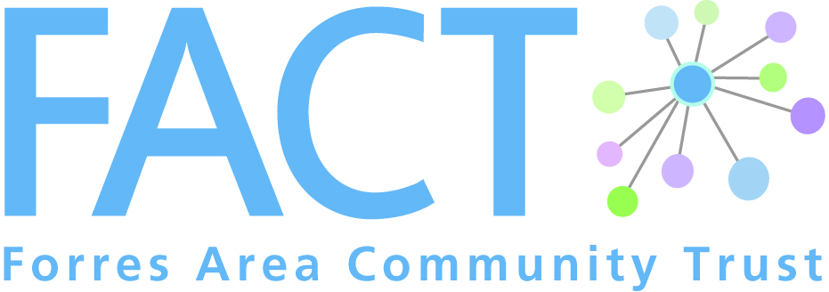
1 Leask Road, Forres, IV36 1SW

Phone: 01309 674388
Email: info@forresarea.org
Web: www.forresarea.org

Cameron’s Champion Role Description

Project Profile
The Spirit of Community – Coming Together Event in October 2014 was a public consultation supported by Forres Area Community Trust (FACT), Forres Area Forum and Findhorn & Kinloss Community Council.
Feedback from the consultation on older people’s activities and services identified befriending as a need in the local area.
FACT have received funding from the Auchernack Trust to meet this need for befriending and to support older people to access services and activities in their local area.
The Auchernack Trust funds came from Mr William Cameron, a former postman of Forres, who made provision in his Will in 1979 for the residue of his estate on death to be used for the benefit of residents of Auchernack Care Home in Forres. After the closure of Auchernack Care home the money was put into trust for the benefit of older people in Forres.
This is why we have chosen to name volunteers for this project Cameron’s Champions.
All volunteers undergo extensive training and are then introduced to a client for the purpose of visiting them in their own homes and/or supporting them to get out and about, to attend activities and services in their local area.
Cameron’s Champions are expected to be able to spend a minimum of 1-2 hours per week/fortnight for a minimum duration of 6 months. The support provided by Cameron’s Champions might include accompanying clients to social events, activities, or perhaps to attend health appointments. Most importantly they will be able to spend valuable time with the client and give individual attention and support.
Cameron’s Champions aim to help clients to build their confidence and to increase their independence by providing a listening ear and encouraging the client to get out and about to rediscover old interests and find new ones.

Cameron’s Champions tasks and responsibilities
- To establish and build a good befriending relationship
- To establish and maintain appropriate boundaries within the befriending relationship
- To spend time/share activities with the client
- To respect confidentiality within the framework of the project
- To be accepting, understanding and non-judgemental
- To acknowledge positive skills and qualities
- To be consistent
- To be reliable
- To work within a non-discriminatory framework
- To notify the Coordinator of any arising issues/difficulties relating to the befriending relationship
- To undertake induction training and any other relevant training
- To adhere to the project’s policies and procedures
- To attend one to one support sessions with the Coordinator and Volunteer support meetings
- To complete the necessary administrative tasks, e.g. contact forms and expenses

