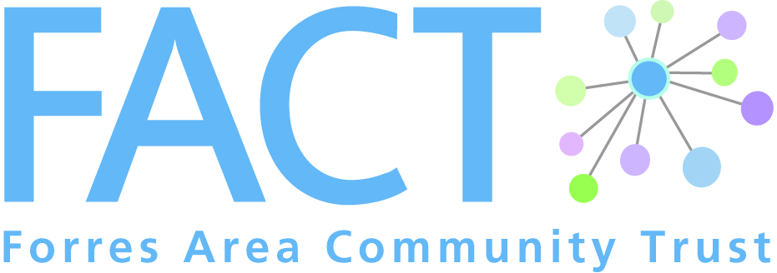
1 Leask Road, Forres, IV36 1SW

Phone: 01309 674388
Email: info@forresarea.org
Web: www.forresarea.org

Cameron’s Champion Supplement

Please tell us a bit about your interests
Activities

Pastimes

Hobbies

Interests

Anything else?

Do you have any strong likes or dislikes? Yes/No

If yes, please give details __________________________________________________________

How would you like to help a client? Please tick all that apply
- Increase social connections | - Support to access local groups/activites
- Attend FACT event | - Visit place of interest
- Shopping (not food shopping) | - Transport/mobility
- Information | - Other (please specify below)

Other: _________________________________________________________________________

Driving
Do you hold a driving licence?
Do you have access to a car?
Would you be willing to transport a client?

Please note:
Volunteers using their own car must check with their insurance company that they are covered for the work they will be doing.
Normally this is not a problem as it is no different to offering a lift to a friend. However, some insurance companies may wish to update their records which may incur an admin fee. Should this be the case, please ask for a receipt as this cost will be covered by FACT up to £30.
We are requested to make a copy for our records of you:
- Driving licence
- MOT certificate
- Road Tax
- Insurance certificate

Data Protection
To comply with the Data Protection Act 1998 we need your consent to hold your personal details at FACT. These details are kept private and confidential and only specific members of staff have access to them. Please sign below if you agree to these terms.

Signature: Date:

