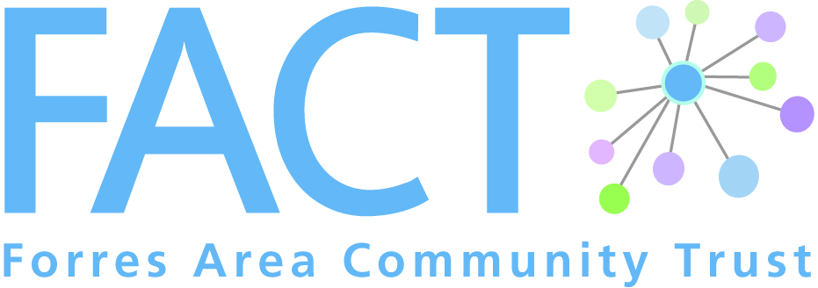
1 Leask Road, Forres, IV36 1SW

Phone: 01309 674388
Email: info@forresarea.org
Web: www.forresarea.org

Cameron’s Project Referral Form

Name
Address

Telephone no.
Email address

Personal details
Date of birth
Gender (please circle) | Male Female
Known health problems
Mobility aids (please circle) | Support cane walking frame wheelchair  none

Emergency contact name
Relationship
Contact details

Current support services
Name | Agency | Type of contact | How often

Reason for referral (what you want us to do)
Please tick all that apply
- Increase social connections | - Support to access local groups/ activities
- Attend FACT event | - Visit place of interest
- Shopping (not food shopping) | - Transport/mobility
- Information | - Other (please specify below)

Other:

Please tell us a bit about your interests past and present
Activities

Pastimes

Hobbies

Interests

Anything else?

Data Protection Act 1998

I understand that this form is part of the referral process to Cameron’s Project delivered by Forres Area Community Trust (FACT). I consent to the above information being passed to this project. I understand that these details will be kept in a locked filing cabinet at the FACT office. I understand that at any time I can request access to this information.
I understand that at any time I can request that my details are no longer kept with the Cameron Project at the FACT office.

Signature Client: Date:

If you were not able to obtain the Client’s signature, please sign underneath to indicate that the client is aware of the referral being made and has given your verbal consent.

Signature Referrer: Date:

